**SET WINDOWS VARIABLE ENVIRONMENT**

1. **Open System Properties box**

Method 1: Search “env” and open “Edit the system environment”

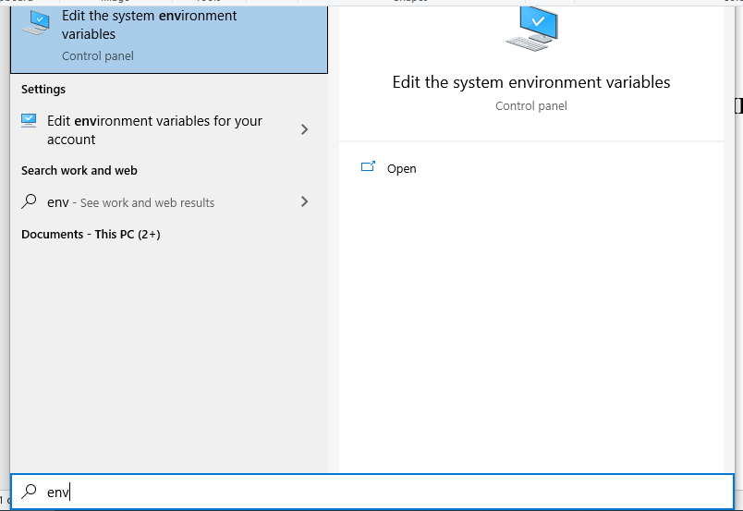

Method 2: Open: Control panel” -> -> System -> Advanced system settings -> Advanced

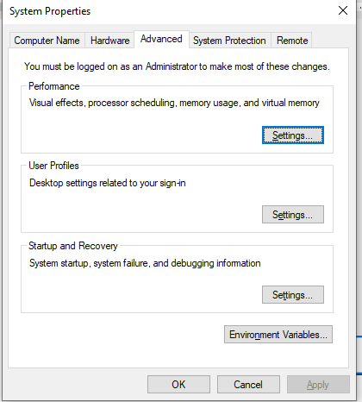

1. **Set path for Environment Variables**

+) Open Environment Variables box

* **Click: Environment Variables -> Path**

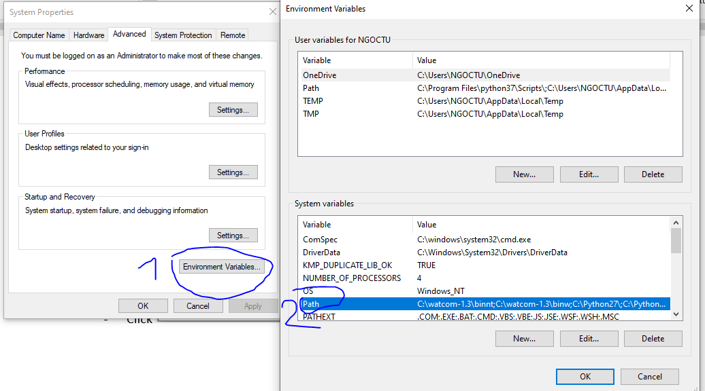

* **Click “new” and add path for executable files which you would like to open in cmd terminal**

(Example g++, gcc in mingw64: add C:\msys64\mingw64\bin and C:\msys64\usr\bin)

